Arduino UNO板硬件

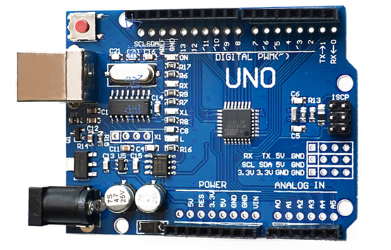

Specifications

|  |  |
| --- | --- |
| Microcontroller | ATmega328 |
| Operating Voltage | 5V |
| Input Voltage (recommended) | 7-12V |
| Input Voltage (limits) | 6-20V |
| Digital I/O Pins | 14 (of which 6 provide PWM output) |
| Analog Input Pins | 6 |
| DC Current per I/O Pin | 40 mA |
| DC Current for 3.3V Pin | 50 mA |
| Flash Memory | 32 KB (ATmega328) of which 0.5 KB used by bootloader |
| SRAM | 2 KB (ATmega328) |
| EEPROM | 1 KB (ATmega328) |
| Clock Speed | 16 MHz |

Digital and Analog PINS

|  |  |
| --- | --- |
| Pin | Funicton |
| D0 | D0/RX |
| D1 | D1/TX |
| D2 | D2/IRQ0 |
| D3~ | D3/IRQ1 |
| D4 | D4 |
| D5~ | D5 |
| D6~ | D6 |
| D7 | D7 |
| D8 | D8 |
| D9~ | D9 |
| D10~ | D10/SS |
| D11~ | D11/MOSI |
| D12 | D12/MISO |
| D13 | D13/SCK |
| A0 | A0 |
| A1 | A1 |
| A2 | A2 |
| A3 | A3 |
| A4 | A4/SDA |
| A5 | A5/SCL |